GEOINT CASE
Operational Assessment of a Regional Distribution Facility (IKEA Logistics)
Throughput and surge capacity of a multimodal regional distribution hub
Japan

Subject | Large regional distribution facility assessed by satellite imagery; a dedicated IKEA distribution office is present on site
Geography | Japan — the source states no coordinates
Imagery basis | High-resolution satellite imagery; single-date capture, time of day not stated
Facility composition | Four large warehouse buildings, multiple trailer yards, a container storage area, a designated waiting area, internal rail connections
Warehouse footprint | ~375,000 m² total
Total dock positions | 405 auto docks; 129 active at time of imaging
Estimated dock utilization | ~32% — approx. 68% dock capacity unused
Stated surge capability | 30-40% increase in throughput without physical expansion

RESEARCH QUESTION
The objective of this analysis is to assess the operational utilization and current workload of a large regional distribution facility using high-resolution satellite imagery.

Prepared from public sources only. No private, paid or non-public data was used.

Objective
The objective of this analysis is to assess the operational utilization and current workload of a large regional distribution facility using high-resolution satellite imagery.
The assessment focuses on:
- Dock utilization
- Trailer yard occupancy
- Container storage density
- Waiting area activity
- Rail usage
- Overall operational capacity and spare throughput potential
The analysis is based on a single-date satellite image and reflects conditions observed at the time of capture.
Figure 1. Facility overview at the time of imaging. Observed: four large warehouse buildings, trailer yards to the north-west and south, a container storage area along a rail spur, and a waiting area on the eastern side. Warehouse footprint is stated in the source as approximately 375,000 m².
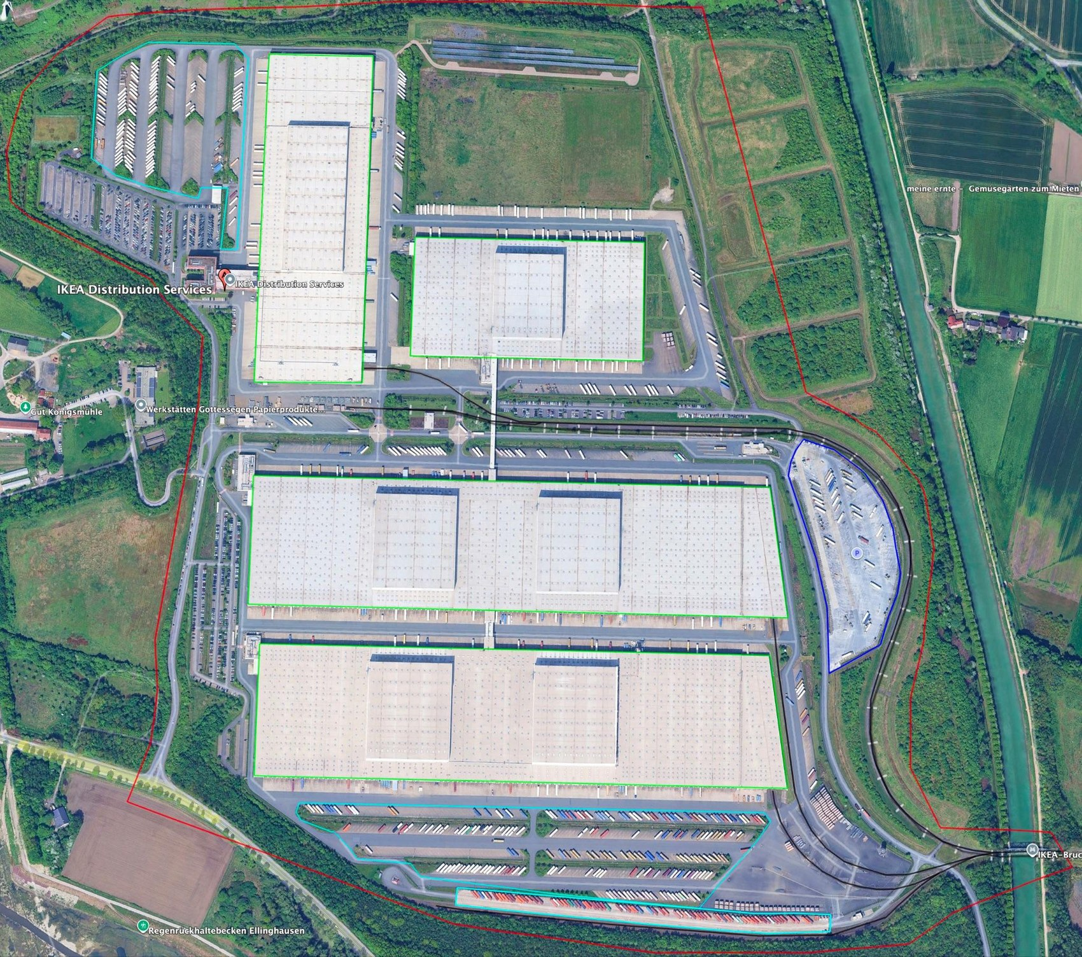
Source: high-resolution satellite imagery reproduced from the source case; provider, platform and acquisition date are not stated in the source and are recorded as unknown. Site boundary and building outlines as drawn in the source imagery. Annotation: none added by the formatter.

Analytical Approach
Operational activity was assessed using multiple independent indicators:

Primary indicator
- Dock occupancy (trailers physically positioned at open dock doors)

Secondary indicators
- Trailer yard density
- Container yard fill level
- Waiting area utilization
Dock positions were counted across all visible warehouse façades. Only docks with both an open door and a positioned trailer were classified as active.
No façades were obscured by shadow or perspective distortion. Visibility conditions were assessed as high.

Facility Overview
The site consists of four large warehouse buildings supported by multiple trailer yards, a container storage area, a designated waiting area, and internal rail connections. The facility functions as a large regional distribution hub , based on:
- Total warehouse footprint (~375,000 m2)
- High dock count
- Multimodal access (truck + rail)
- Presence of a dedicated IKEA distribution office

Dock Utilization
Figure 2. Total auto dock positions and docks active at the time of imaging, all warehouses
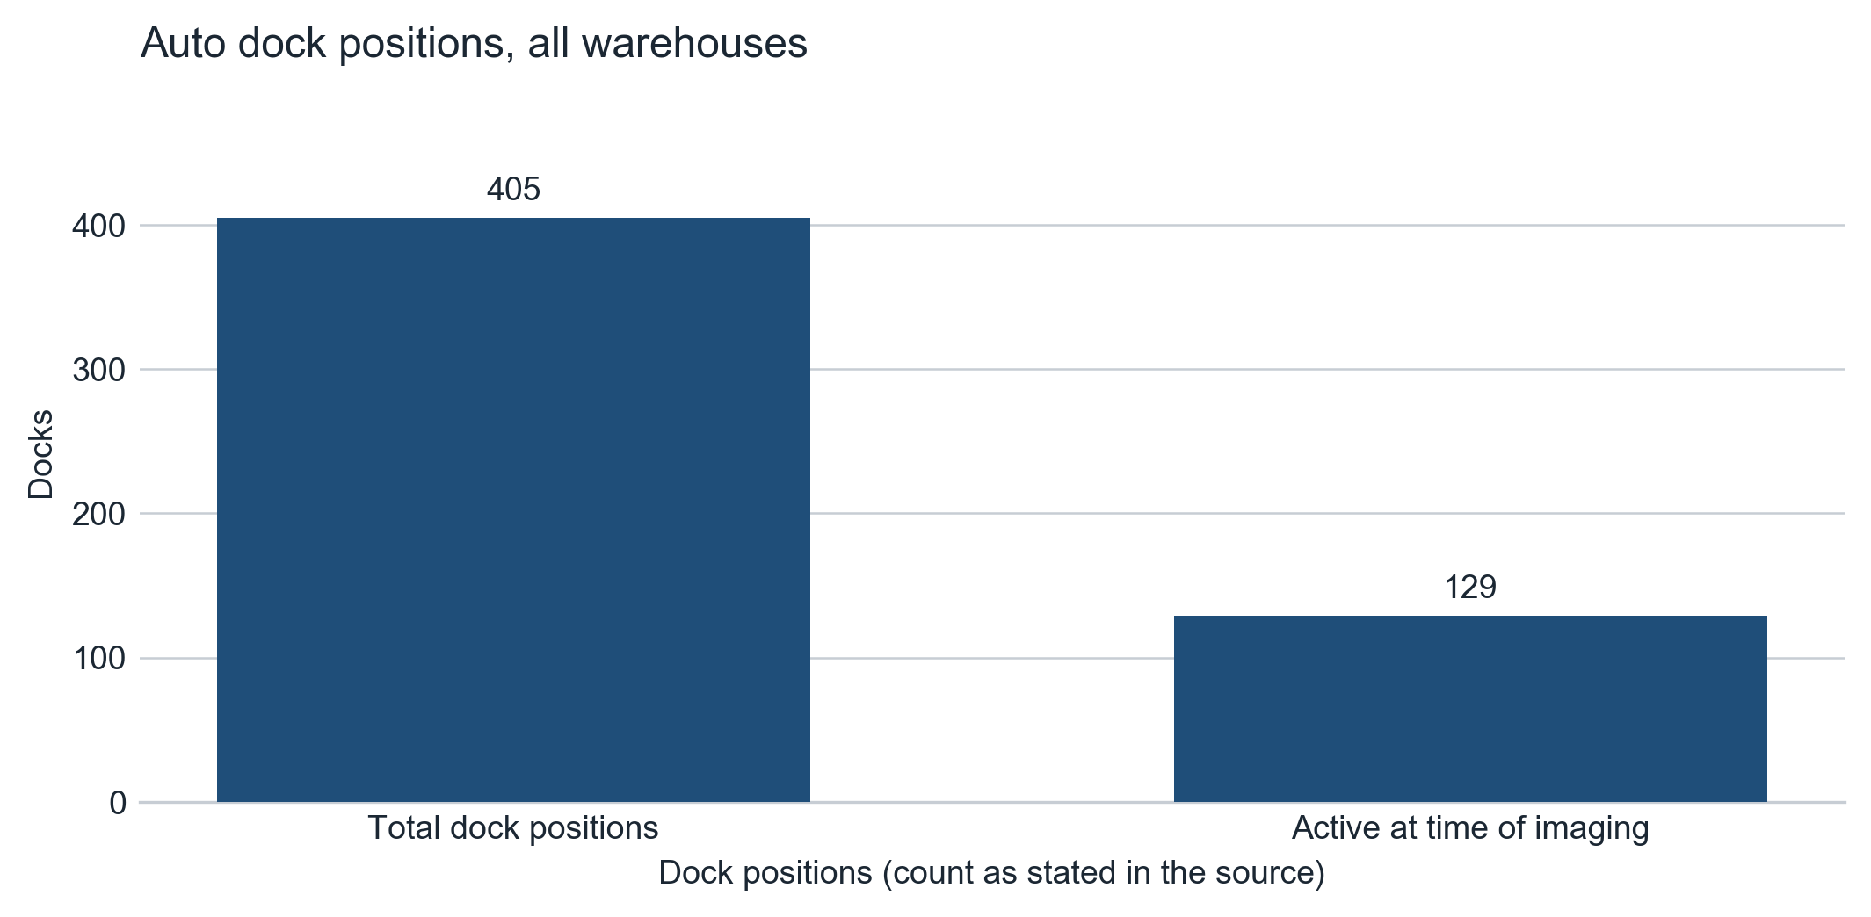
Source: source case, Dock Utilization. Values as stated in the source: 405 total auto dock positions, 129 active, estimated dock utilization ~32%.
Table 1. Dock positions and activity, all warehouses
Measure | Value as stated in the source
Total auto dock positions across all warehouses | 405
Active at time of imaging | 129
Estimated dock utilization | ~32%

Large numbers of empty dock positions were observed across all buildings, indicating significant available processing capacity.

Warehouse Breakdown
Table 2. Dock positions and active docks by warehouse
Façade / facility element | Docks | Active
Warehouse 1 — north docks | 98 | 18
Warehouse 1 — south docks | 98 | 14
Warehouse 2 — north docks | 98 | 19
Warehouse 2 — south docks | 97 | 25
Warehouse 3 — west docks | 61 | 12
Warehouse 3 — east docks | 60 | 7
Warehouse 4 — north docks | 46 | 16
Warehouse 4 — south docks | 42 | 18
Rail docks — Warehouse 1 | 2 | not stated
Rail docks — Warehouse 2 | 2 | not stated
Rail docks — Warehouse 3 | 2 | not stated
Rail connection — Warehouse 4 | No rail connection | —

Figure 3. Active docks by warehouse façade at the time of imaging
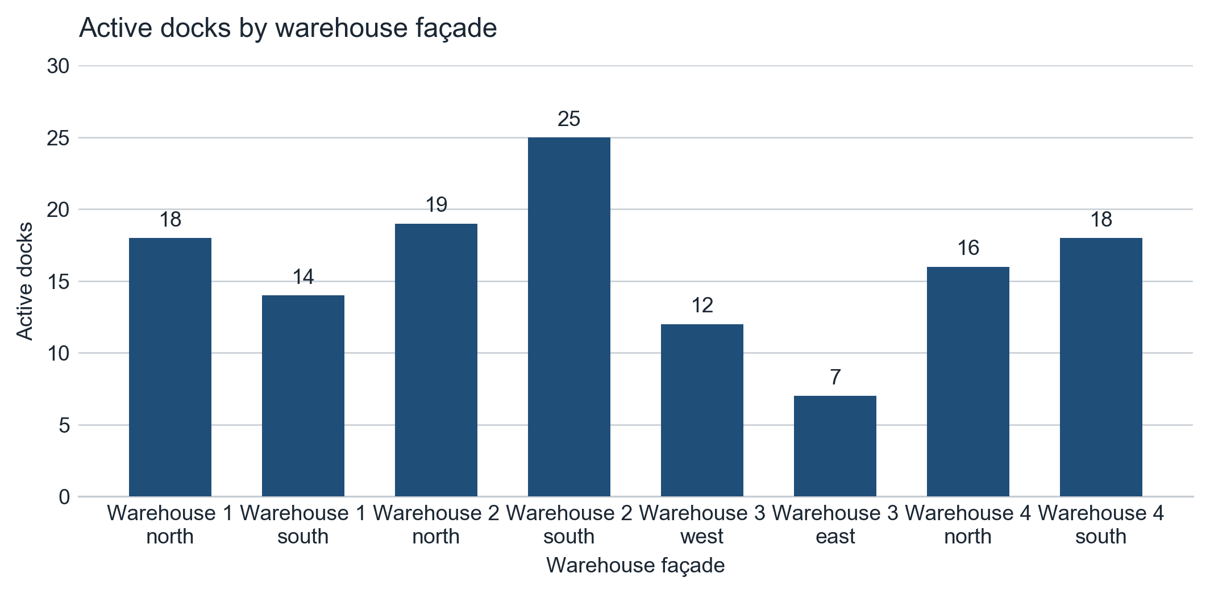
Source: source case, Warehouse Breakdown. Counts as stated in the source; the source states no façade-level activity rate. The sum of the façade counts is not reconciled here against the stated total of 405 auto dock positions.

Warehouse 1
- 98 north docks (18 active)
- 98 south docks (14 active)
- 2 rail docks

Warehouse 2
- 98 north docks (19 active)
- 97 south docks (25 active)
- 2 rail docks

Warehouse 3
- 61 west docks (12 active)
- 60 east docks (7 active)
- 2 rail docks

Warehouse 4
- 46 north docks (16 active)
- 42 south docks (18 active)
- No rail connection
Overall dock activity levels are low to moderate , with significant spare handling capacity.

Yard and Staging Areas
Trailer yard utilization varies across the facility but remains below full capacity.

Southern Trailer Yard
Approximate area: 60,000 m2 Estimated utilization: ~75%

Northwest Trailer Yard
Approximate area: 45,000 m2 Estimated utilization: 40-50%
Figure 4. Northern part of the facility. Observed: warehouse 3 and warehouse 4 outlines, the north-west trailer yard, and trailers in the northern staging lanes. Labels are as drawn in the source imagery.
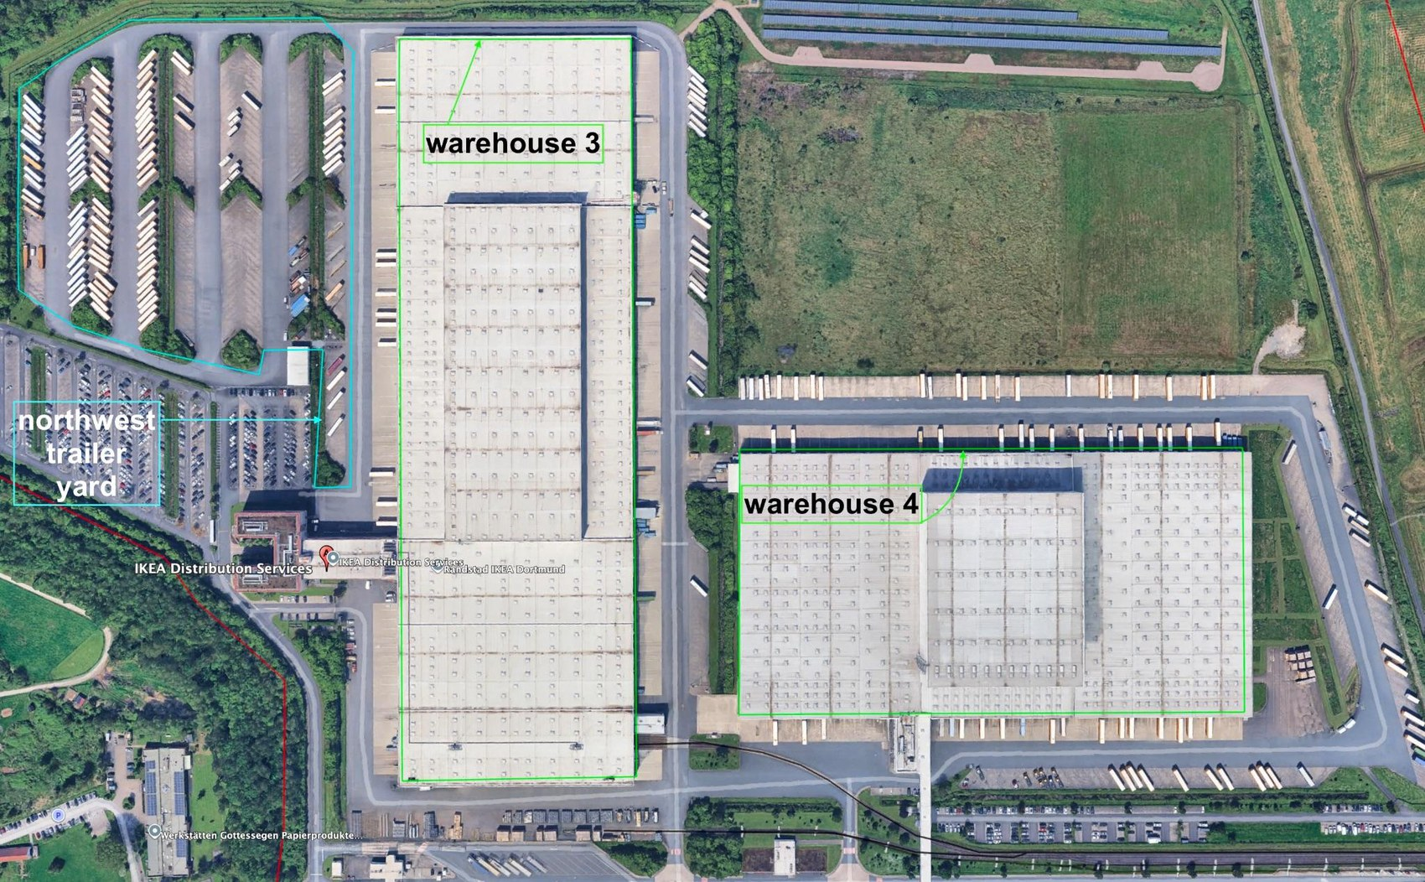
Source: high-resolution satellite imagery reproduced from the source case; provider, platform and acquisition date are not stated in the source and are recorded as unknown. Site boundary and building outlines as drawn in the source imagery. Annotation: none added by the formatter.

Waiting Area (Eastern Zone)
Approximate area: 30,000 m2 Estimated utilization: 15-20%
Only heavy vehicles (trailers and tractor-trailer combinations) were observed.
Low occupancy suggests limited inbound queuing pressure .

Container Storage and Rail Activity
The southern part of the facility contains a linear container storage area positioned along a rail spur.
- Container storage length: ~500 m
- Ground storage nearly fully occupied
- No railcars observed on tracks at time of imaging
This indicates:
- Active container throughput capability
- No rail movement at the moment of capture
- Rail infrastructure remains operational based on layout and cargo positioning
Figure 5. Southern part of the facility. Observed: warehouse 1 and warehouse 2 outlines, the south trailer yard, the south container yard with containers ranked along the rail spur, and the waiting area on the eastern side. Labels are as drawn in the source imagery.
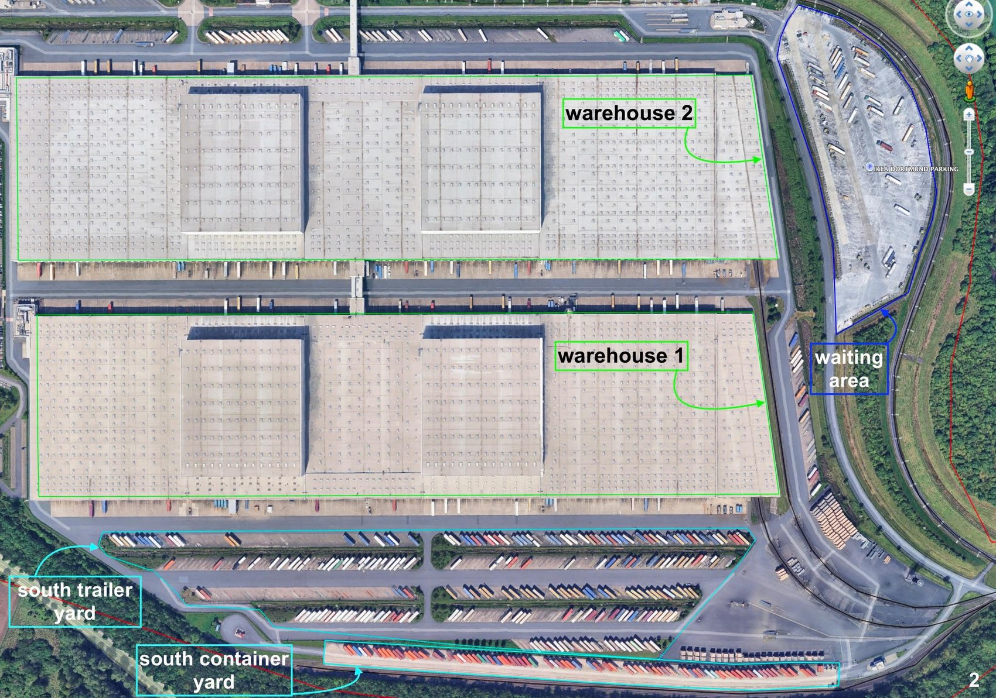
Source: high-resolution satellite imagery reproduced from the source case; provider, platform and acquisition date are not stated in the source and are recorded as unknown. Site boundary and building outlines as drawn in the source imagery. Annotation: none added by the formatter.

Rail Assessment
Rail lines connect directly to Warehouses 1, 2, and 3.
Although no rolling stock was observed, the following indicators suggest operational use:
- Internal rail penetration into buildings
- Container staging aligned with rail spur
- Dedicated rail dock positions
Assessment:
Assessment
Rail active periodically but not continuously

Integrated Operational Assessment
Indicators observed:
Table 3. Operational indicators observed in the imagery
Indicator | Assessment
Dock utilization | Low-Moderate (~32%)
Trailer yards | Partially filled
Container yard | High occupancy
Waiting area | Low utilization
Rail activity | No movement observed

Overall interpretation:
The facility was operating at a moderate workload level with substantial spare processing capacity at the time of imaging.
Activity pattern suggests:
- Stable throughput
- No congestion or surge conditions
- Capacity available for demand increase

Surge Capacity Assessment
Given:
- ~68% dock capacity unused
- Partially filled trailer yards
- Low waiting area pressure
Assessment
The facility is assessed capable of handling a 30-40% increase in throughput without physical expansion.

Confidence Assessment
Table 4. Confidence by analytical component
Component | Confidence
Dock count accuracy | High
Dock activity classification | High
Yard occupancy estimates | Medium-High
Container density assessment | High
Rail usage interpretation | Medium
Overall operational assessment | Medium-High

Limitations
- Single-date imagery
- Unknown time of day
- No historical activity baseline

Conclusion
The analyzed facility represents a large multimodal regional distribution hub currently operating below maximum capacity. Low dock utilization combined with moderate yard loading and minimal queuing indicates stable operations with significant available throughput margin. The site is well-positioned to absorb near-term demand increases without infrastructure expansion.

